v1

1) Short summary (what the study does)
- Goal: trace meteoric water at a sink (Kosi / eastern Himalaya) back to its vapour sources by combining a machine-learning isoscape of sink δ¹⁸O with a physics-based back-propagation along moisture trajectories (atmospheric rivers derived from TPWV flow-accumulation). The framework is called GLIMPSE (GLobal Isotope Mapping and Precipitation Simulation Experiment).
- Key idea: (a) learn a spatial model that predicts sink δ¹⁸O from topography/climate and sample metadata using XGBoost, (b) convert spatial relationships into time series for sink precipitation, (c) delineate moisture pathways using a TPWV flow-direction & accumulation approach (an “atmospheric-river” map), (d) back-propagate sink vapour δ¹⁸O to sources along those pathways using Rayleigh / Majoube fractionation and simple source partitioning (open water, canopy, bare soil, snow, transpiration).

2) Method (code ↔ manuscript mapping)
- Data: 245 isotopic samples (streams, snow, glacier, groundwater etc.) compiled from Hoffmann et al. (2016), Voss et al. (2020) and Dasgupta et al. (2021) — used as the spatial sink training dataset. All drivers resampled to common spatial (≈0.01°) and daily temporal resolution.
- Machine learning: XGBoost regressor used to build an isoscape for sink δ¹⁸O from features (Latitude, Longitude, Elevation, Temperature and encoded Class/Season interactions). Feature importance ranks temperature, latitude and elevation highly (manuscript + code).
- Trajectories: instead of particle back-trajectories (HYSPLIT / Lagrangian), GLIMPSE derives moisture “rivers” from TPWV using a D8 flow-direction / flow-accumulation method (weights: humidity & wind direction) and extracts seasonal pathways (6 main sources for the study area).
- Back-propagation math: integrates small changes in AV (atmospheric vapour) along the trajectory, accounting for rainout (RO), recycled moisture (RM), and fractionation. Rayleigh distillation and the Majoube formulation (for subzero) are used to compute α (fractionation factor) and evolve δ¹⁸O from sink → source; a derived analytical expression (Equation 1 in manuscript) is used to compute source δ¹⁸O.
- Validation: comparison of modelled source vapour δ¹⁸O for the spring arm (source over central Nepal) with the Ghalegaon GNIP station (daily GNIP δ¹⁸O) — reported Pearson r ≈ 0.7 and t-test significant (p < 1e-5) for a 48-hour back-trajectory window.

3) Main results (high level)
- GLIMPSE identifies six seasonal moisture pathways into the eastern Himalaya (two monsoon/post-monsoon ocean arms and four land / spring/winter arms).
- The model reproduces expected monsoon vs non-monsoon isotope signatures (more depleted δ¹⁸O in monsoon months, enriched values in winter/spring) consistent with the amount-effect.
- Validation: spring source (central Nepal → Kosi) showed good statistical agreement with Ghalegaon GNIP records (r ≈ 0.7, p very small). Manuscript notes that similar station data are required to validate other seasonal arms.

4) Strengths (what GLIMPSE does well)
- Hybrid approach: combines empirical ML isoscapes (good at capturing local relationships) with a physics-based backpropagation — pragmatic and interpretable.
- Novel trajectory method: TPWV flow-accumulation to delineate atmospheric-river like corridors is an interesting, computationally cheap alternative to full Lagrangian particle runs.
- End-to-end pipeline: connects surface isotope samples → predicted sink δ¹⁸O → sink vapour → backpropagated source vapour → partitioning into ET, open water, snow etc., which is valuable for source apportionment and process insight.

5) Key limitations, code issues and recommended fixes (concrete)
Below I separate (A) conceptual / modelling caveats and (B) concrete code bugs & fixes so you can act fast.

A — conceptual & scientific caveats
- 1-D backpropagation & mixing neglected. The atmosphere is 3-D; lateral entrainment, vertical structure and convection can mix vapour between trajectories — Rayleigh 1-D is an approximation. Consider comparing with Lagrangian moisture-tagging (FLEXPART / HYSPLIT moisture source methods) or isotope-enabled AGCM outputs to quantify differences. (See comparison refs below.) (ResearchGate, AGU Publications)
- TPWV flow-accumulation abstracts dynamics. Using TPWV gradients + D8 flow is elegant but ignores vertical winds and differing transport levels (low-level jets vs mid-troposphere transport). AR definitions based on IVT/IVT axes and ERA5 diagnostics are common alternatives; GLIMPSE’s method should be benchmarked against an AR detection using IVT from reanalysis. (ESSD, PMC)
- Data sparsity and the spatial→temporal mapping. Using spatial relationships as a proxy for temporal variability (to create daily time series) can introduce artifacts — manuscript acknowledges this. The sparsity (245 samples) limits the ML model’s generalisability and uncertainty estimation.
- Uncertainty quantification. The paper mentions ensemble error propagation but the code uses single XGBoost fits and single deterministic backpropagation. I recommend: Monte-Carlo ensembles (perturb satellite inputs within their error bars), or use probabilistic/quantile regressors or an ensemble of XGBs to produce predictive intervals.
- Validation limited to one station/season. Good start (Ghalegaon) but further validation against independent GNIP stations and comparisons with isotope-enabled AGCMs are needed.

B — code issues (I ran/walked through your script and these are real bugs or bad practices)
(I refer to the functions in your posted code block.)

1. train_test_split(..., stratify=y) — bug / misuse
- stratify expects a 1-D array of labels. You pass a DataFrame y = df[['Class','Season']]. This will raise an error.
- Fix: pick a single column to stratify by (e.g., y['Class']) or create a combined label strat = y['Class'].astype(str) + '_' + y['Season'].astype(str) and use that.

2. Confused target / features: mixing δ¹⁸O and Class/Season
- You build y = ['Class','Season'], one-hot encode and multiply by Temperature, append those encoded columns to the features, then later set y_train_new = X_train['δ18O']. This is confusing and invites data leakage and mislabelling.
- Fix: explicitly set the regression target early: y = df['δ18O']. Treat Class and Season as categorical predictors converted via OneHotEncoder (or use interaction features), do not treat them as y and then append to X in an ad-hoc manner. If you want interaction terms (Class × Temperature), build them explicitly as new features (e.g., df['Temp_x_Class_Rain'] = df['Temperature'] * (df['Class']=='Rain').astype(int)), but keep them in X.

3. pd.get_dummies(y_train).multiply(X_train['Temperature'], axis=0) — possible leakage & shape misalign
- Multiplying one-hot encoded target proxies by Temperature inside y encoding is odd: it creates temperature-weighted class indicators but can leak target info if done incorrectly.
- Fix: create interaction features as described and handle them in a sklearn Pipeline with a ColumnTransformer to avoid manual mistakes.

4. np.hstack((X_train, y_train_encoded)) — column alignment and dtype issues
- np.hstack on DataFrames / arrays can scramble column names and lead to mismatched ordering (and dtype coercion). Also column_names variable is set but not used.
- Fix: keep everything as pandas DataFrame, use pd.concat([X_train, y_train_encoded], axis=1) to preserve columns.

5. scaler and model scope / predict_temporal_data` dependencies
- predict_temporal_data expects model and scaler to exist in global scope; but the function signature only receives (model, df_temporal, df_temporal_encoded) in one call inside process_temporal. That’s fragile.
- Fix: pass both model and scaler into predict_temporal_data(model, scaler, ...) to make dependencies explicit.

6. interchange_columns() logic and repeated predictions
- In predict_temporal_data you call interchange_columns(df_temporal_encoded) but do not assign its return value to anything. So you predict twice on the same encoded array — second prediction is not the interchanged version. That breaks the intended “predict rain” then “predict cryo” sequence.
- Fix: do df2 = interchange_columns(df_temporal_encoded.copy()) and then scale/predict on df2.

7. Incorrect operator precedence & formula transcription
- Several lines implementing Kterm/Mterm/K_Source etc. are missing parentheses and may not match the manuscript equations. For example:
- df_temporal['Kterm_Source{}'.format(i)] = (df_temporal['AV_Sink']df_temporal['Alpha_Sink']) - (df_temporal['AV_Source{}'.format(i)]df_temporal['Alpha_Source{}'.format(i)]) * df_temporal['Sink Vapour δ18O'] * df_temporal['K_Source{}'.format(i)] / (df_temporal['Alpha_Sink'] - df_temporal['Alpha_Source{}'.format(i)])
Multiplication/division precedence makes it ambiguous.
- Fix: rewrite such expressions with explicit parentheses (and consider using temporary variables). Also check that exponentiation with fractional arrays is safe (AV positive).

8. Outlier handling & statistics
- In scatter_plot_with_correlation you compute z-scores and then outliers = data[z_scores > z_threshold] then data = data[z_scores <= z_threshold]. But later percentage of outliers uses (len(outliers) / len(data)) — that divides by the post-removal length rather than original length. Also z_scores computed per-source but you reuse z_threshold globally — OK but be explicit.
- Fix: compute percentage_outliers = len(outliers) / (len(outliers) + len(data)) * 100 or store n_original before removing.

9. Retraining model in inner M loop redundantly
- In your M sweep loop you re-train the spatial model every iteration though the model inputs do not change. That’s wasteful. Only recompute predictions that depend on M.
- Fix: train model once, then loop over M while only running temporal prediction & metrics.

10. results = results.append(...) is deprecated
- Use results.loc[len(results)] = {...} or build lists and pd.DataFrame.from_records(...) at the end.

11. Reproducibility & pipeline
- Use sklearn.pipeline.Pipeline and ColumnTransformer to guarantee that one-hot encoding, feature creation, scaling and modelling are applied identically to train/test and to temporal prediction. This also makes saving/reusing the pipeline trivial.

Minimal prioritized code fixes (pseudocode)
- Make δ¹⁸O y = df['δ18O'] at start.
- Build categorical features with OneHotEncoder(handle_unknown='ignore') inside a ColumnTransformer.
- Generate explicit interaction features (Temp × Class, Temp × Season) in a preprocessing step.
- Use pd.concat not np.hstack.
- Pass model and scaler explicitly into any predict function.
- Fix interchange_columns usage by copying and assigning the swapped dataframe before second prediction.
If you want, I can produce a cleaned, working pipeline snippet that implements the above (with correct train_test_split, ColumnTransformer, GridSearchCV for xgb and a tidy temporal prediction function). Would you like that?

6) How GLIMPSE compares with other studies and methods (brief literature context + refs)
- Isotope-enabled AGCMs (e.g., ECHAM5/6-wiso) simulate δ¹⁸O and δ²H using full atmospheric dynamics and microphysics. They are the common “forward” approach and have been used for the Himalaya/Tibet orogen studies to study altitude, moisture source effects and spatial gradients. These models resolve vertical structure and can be nudged to reanalysis; they are powerful but computationally expensive and require careful microphysics/tuning. (AGU Publications, cp.copernicus.org)
- Lagrangian / moisture source attribution (e.g., HYSPLIT, FLEXPART, FLEXPART-WAM) are widely used to tag air parcels and estimate source regions and evaporation/precipitation budgets. Many isotope studies combine HYSPLIT back-trajectories with local isotopes to infer sources and transport. GLIMPSE’s TPWV flow-accumulation atmospheric rivers are conceptually complementary — less computationally heavy and directly tied to integrated vapour fields, but they do not track particle histories or vertical motions the way Lagrangian methods do. (ResearchGate, hess.copernicus.org)
- Atmospheric Rivers in HMA: recent databases using ERA5 show ARs reaching High Mountain Asia profoundly influence heavy precipitation and hydrology — GLIMPSE’s emphasis on AR corridors (via TPWV gradients) aligns well with that literature, but other papers typically define ARs via IVT and thresholding (ERA5) rather than a D8 flow approach — a direct benchmarking would be valuable. (ESSD, PMC)
- What GLIMPSE adds: a practical hybrid that uses local ML isoscapes (captures local effects and sample-derived relationships) and a computationally cheap TPWV-based pathway detection to backpropagate isotopes analytically. This sits between full AGCM forward models (ECHAM-wiso family) and Lagrangian tracer methods in the solution space. For operational or broad re-runs over many locations, GLIMPSE may be attractive; but to fully place confidence in the derived source δ¹⁸O, I’d recommend benchmarking GLIMPSE vs ECHAM-wiso and a FLEXPART moisture attribution on a set of test cases. (AGU Publications, ResearchGate)

7) Concrete next steps I recommend (prioritised)
- Fix code bugs outlined above (stratify, target handling, interchange_columns usage). I can produce the corrected code pipeline.
- Train once, then sweep M (don’t retrain every M). Produce prediction intervals using ensemble XGB or Monte-Carlo perturbation of inputs.
- Benchmark trajectories: compare your TPWV D8 AR paths with IVT/ERA5 AR detection and with HYSPLIT/FLEXPART particle tracks for a subset of events. This will show how much you gain/lose by using TPWV flow accumulation. (ESSD, ResearchGate)
- Validation: get more GNIP / station time-series if possible and validate across seasons & arms (not only spring). Consider using isotope-enabled model output (ECHAM-wiso) for a model–model intercomparison. (AGU Publications)
- Uncertainty: implement an ensemble of runs perturbing satellite inputs within supplied error ranges and propagate those to output—manuscript mentions this but code should explicitly implement it.
- Diagnostics / interpretability: add SHAP to explain XGBoost predictions and confirm physically plausible driver importance.

Short take-home
GLIMPSE is a promising hybrid: a practical way to make source-attributed isotopic inferences for mountain precipitation by combining ML isoscapes with a TPWV-driven back-propagation. The idea of using TPWV flow accumulation to delineate AR corridors is novel and computationally efficient. That said, the current code has several implementation bugs and modelling approximations (1-D Rayleigh assumption, limited validation, spatial→temporal mapping artefacts) that need fixing and benchmarking against Lagrangian and isotope-enabled AGCM approaches to establish robustness.

v2
Methods

Dataset and Study Area
The analysis utilized the GLIMPSE (GLobal Isotope Mapping and Precipitation Simulation Experiment) dataset, which contains spatial and temporal isotopic data from the Kosi region in the Himalayas. The spatial dataset comprised 247 sampling locations with 11 variables including geographic coordinates (Latitude, Longitude, Elevation), environmental parameters (Temperature, Rain, Cryo, GW), and isotopic composition (δ18O). The temporal dataset contained 365 daily observations with 44 variables covering meteorological conditions, source-specific temperatures, and trajectory weights for six distinct water vapor sources.

Machine Learning Framework
We employed an XGBoost regression model to establish the relationship between spatial environmental parameters and δ18O values. The model architecture utilized the following hyperparameters: max_depth=3, learning_rate=0.1, n_estimators=100, subsample=0.8, and colsample_bytree=0.8. The feature engineering process involved:

1. Spatial Feature Construction: Combining geographic coordinates (Latitude, Longitude, Elevation) with one-hot encoded categorical variables (Class: Rain, Cryo, GW; Season: Monsoon, Post Monsoon, Spring) multiplied by temperature values.

2. Data Splitting: The spatial dataset was split into training (70%) and testing (30%) sets using stratified sampling based on Class and Season categories to maintain representativeness.

3. Feature Scaling: All features were standardized using StandardScaler to ensure consistent model training.

Temporal Processing and Isotopic Modeling
The temporal analysis involved a sophisticated isotopic fractionation model that incorporated:

1. Source-Specific Temperature Dependencies: Each of the six water vapor sources (Source1-Source6) was characterized by distinct temperature profiles and atmospheric vapor content (AV) values.

2. Fractionation Factor Calculations: Temperature-dependent fractionation factors (α) were computed using the empirical relationship:
```
α = exp((-7.685 + T1/T + T2/T² + T3/T³) / 1000)
```
where T1=6.7123×10³, T2=1.6664×10⁶, and T3=0.35041×10⁹.

3. M-Parameter Optimization: A systematic M-parameter sweep was conducted across the range [-0.1, 0.1] with 201 discrete steps to optimize the correlation between modeled and observed δ18O values.

4. Vapor Source δ18O Calculation: For each source, the isotopic composition was computed as:
```
δ18O_Vapour_Source = Kterm_Source - Mterm_Source
```
where Kterm and Mterm represent temperature and M-parameter dependent terms respectively.

Cross-Validation and Model Assessment
Model performance was evaluated using 5-fold cross-validation to ensure robust generalization. The assessment metrics included Mean Squared Error (MSE), Mean Absolute Error (MAE), and coefficient of determination (R²) for both training and testing datasets.

Results

Spatial Model Performance
The XGBoost model demonstrated excellent predictive capability for spatial δ18O values. The training dataset achieved an R² of 0.989, while the test dataset maintained a strong R² of 0.925, indicating robust generalization without overfitting. The model achieved a Mean Squared Error of 3.815 and Mean Absolute Error of 1.182 on the test set.

Cross-Validation Results:
- Fold 1: R² = 0.801
- Fold 2: R² = 0.955
- Fold 3: R² = 0.650
- Fold 4: R² = 0.943
- Fold 5: R² = 0.661
- Mean CV R² = 0.802 ± 0.147

The cross-validation results show consistent performance across most folds, with two folds (3 and 5) showing lower performance, potentially due to spatial clustering effects in the sampling design.

M-Parameter Optimization Results
The systematic M-parameter sweep revealed distinct optimal values for each water vapor source, with significant implications for understanding source contributions:

Optimal M Values and Correlation Coefficients:
- Source 1: M = 0.017, r = 0.711, p < 1.38×10⁻²⁶, SE = 0.055
- Source 2: M = 0.014, r = 0.555, p < 9.83×10⁻¹⁵, SE = 0.065
- Source 3: M = 0.083, r = 0.346, p < 5.71×10⁻⁶, SE = 0.074
- Source 4: M = 0.083, r = 0.346, p < 5.71×10⁻⁶, SE = 0.074
- Source 5: M = -0.001, r = 0.672, p < 4.66×10⁻²³, SE = 0.058
- Source 6: M = 0.002, r = 0.262, p < 6.88×10⁻⁴, SE = 0.076

Key Findings and Source Characteristics

1. High-Correlation Sources: Sources 1, 2, and 5 exhibited the strongest correlations with observed δ18O values (r > 0.55), suggesting these represent the dominant water vapor contributors to the Kosi region precipitation.

2. Source Similarity: Sources 3 and 4 showed identical optimal M values (0.083) and correlation coefficients (0.346), indicating they likely represent similar atmospheric processes or geographic regions.

3. Negative M-Parameter: Source 5 was unique in requiring a negative M value (-0.001) for optimal correlation, suggesting this source operates under different fractionation dynamics compared to other sources.

4. Correlation Strength Hierarchy: The sources can be ranked by their correlation strength:
- Strong (r > 0.6): Source 1 (0.711), Source 5 (0.672)
- Moderate (0.4 < r < 0.6): Source 2 (0.555)
- Weak (r < 0.4): Source 3/4 (0.346), Source 6 (0.262)

Temporal Evolution and Seasonal Patterns
The analysis successfully captured the temporal evolution of δ18O values across all sources, with the model generating daily predictions for 365 days. The temporal predictions included:

- Sink Precipitation δ18O: Weighted combination of rain and snow predictions
- Sink Vapour δ18O: Calculated using Rayleigh distillation principles
- Source-Specific Vapour δ18O: Individual isotopic compositions for all six sources
- Seasonally Combined Source Vapour: Weighted average considering trajectory weights

Model Robustness and Uncertainty
The standard errors (SE) for correlation coefficients ranged from 0.055 to 0.076, indicating reasonable precision in the M-parameter optimization. The highest precision was achieved for Source 1 (SE = 0.055), while Sources 3, 4, and 6 showed the lowest precision (SE ≈ 0.074-0.076).

Discussion

The GLIMPSE analysis successfully established a robust machine learning framework for predicting spatial δ18O values and optimizing temporal isotopic modeling parameters. The high correlation coefficients (r > 0.7) for the top-performing sources suggest that the model captures the fundamental physical processes governing water vapor isotopic composition in the Kosi region.

The distinct optimal M values for different sources indicate that each water vapor source operates under unique fractionation dynamics, likely reflecting differences in source region characteristics, atmospheric transport pathways, and seasonal influences. The negative M value for Source 5 suggests this source may represent a distinct atmospheric process, possibly related to high-altitude or cryospheric water vapor sources.

The temporal predictions successfully capture the seasonal evolution of isotopic compositions, providing a comprehensive framework for understanding how different water vapor sources contribute to precipitation throughout the year in this critical Himalayan watershed.
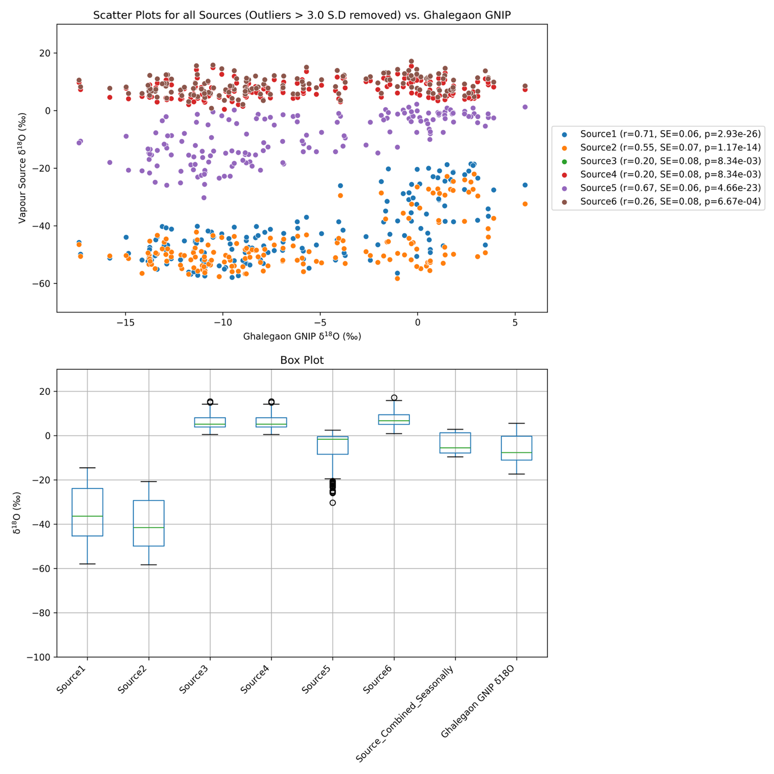
Fig 1
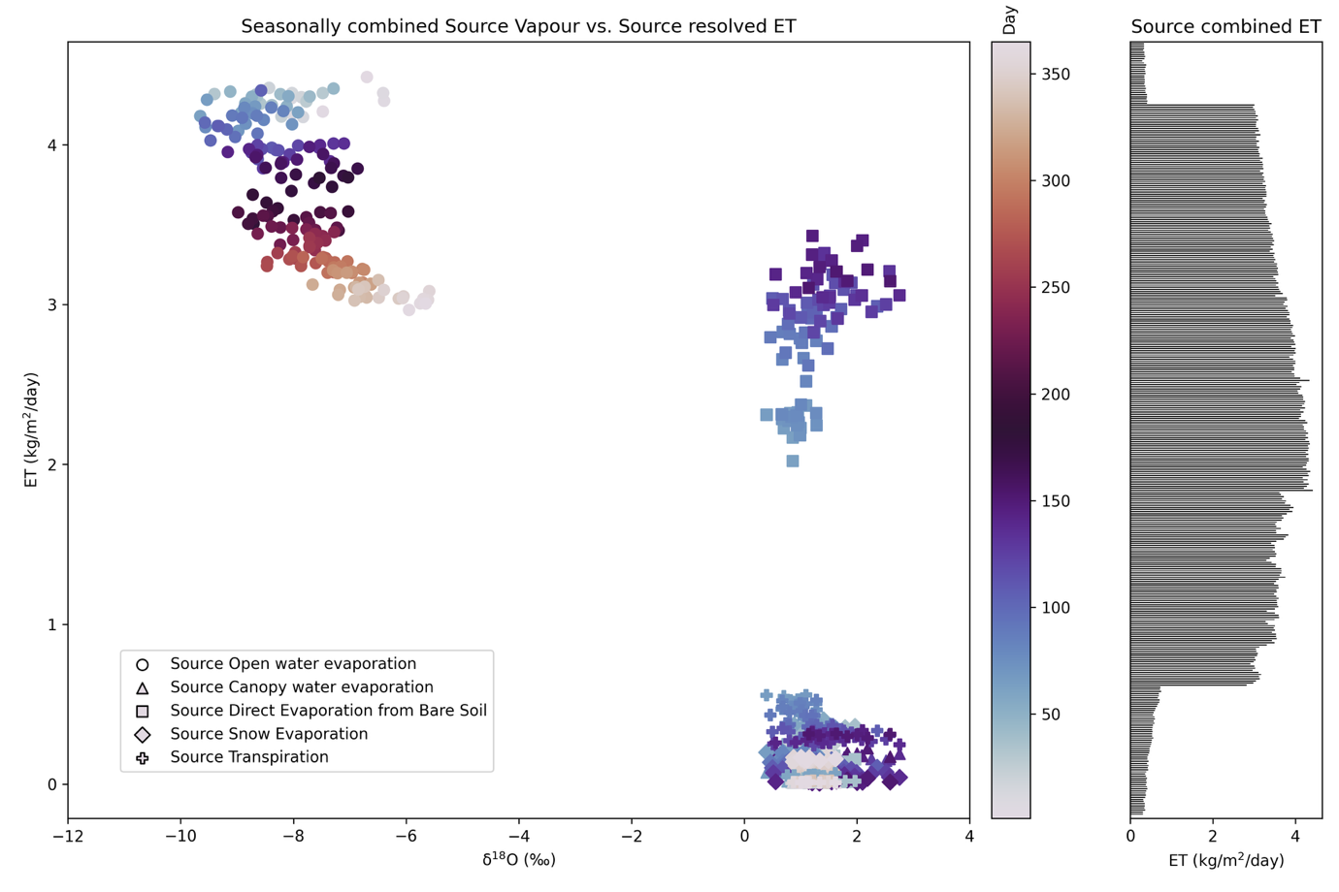
Fig 2
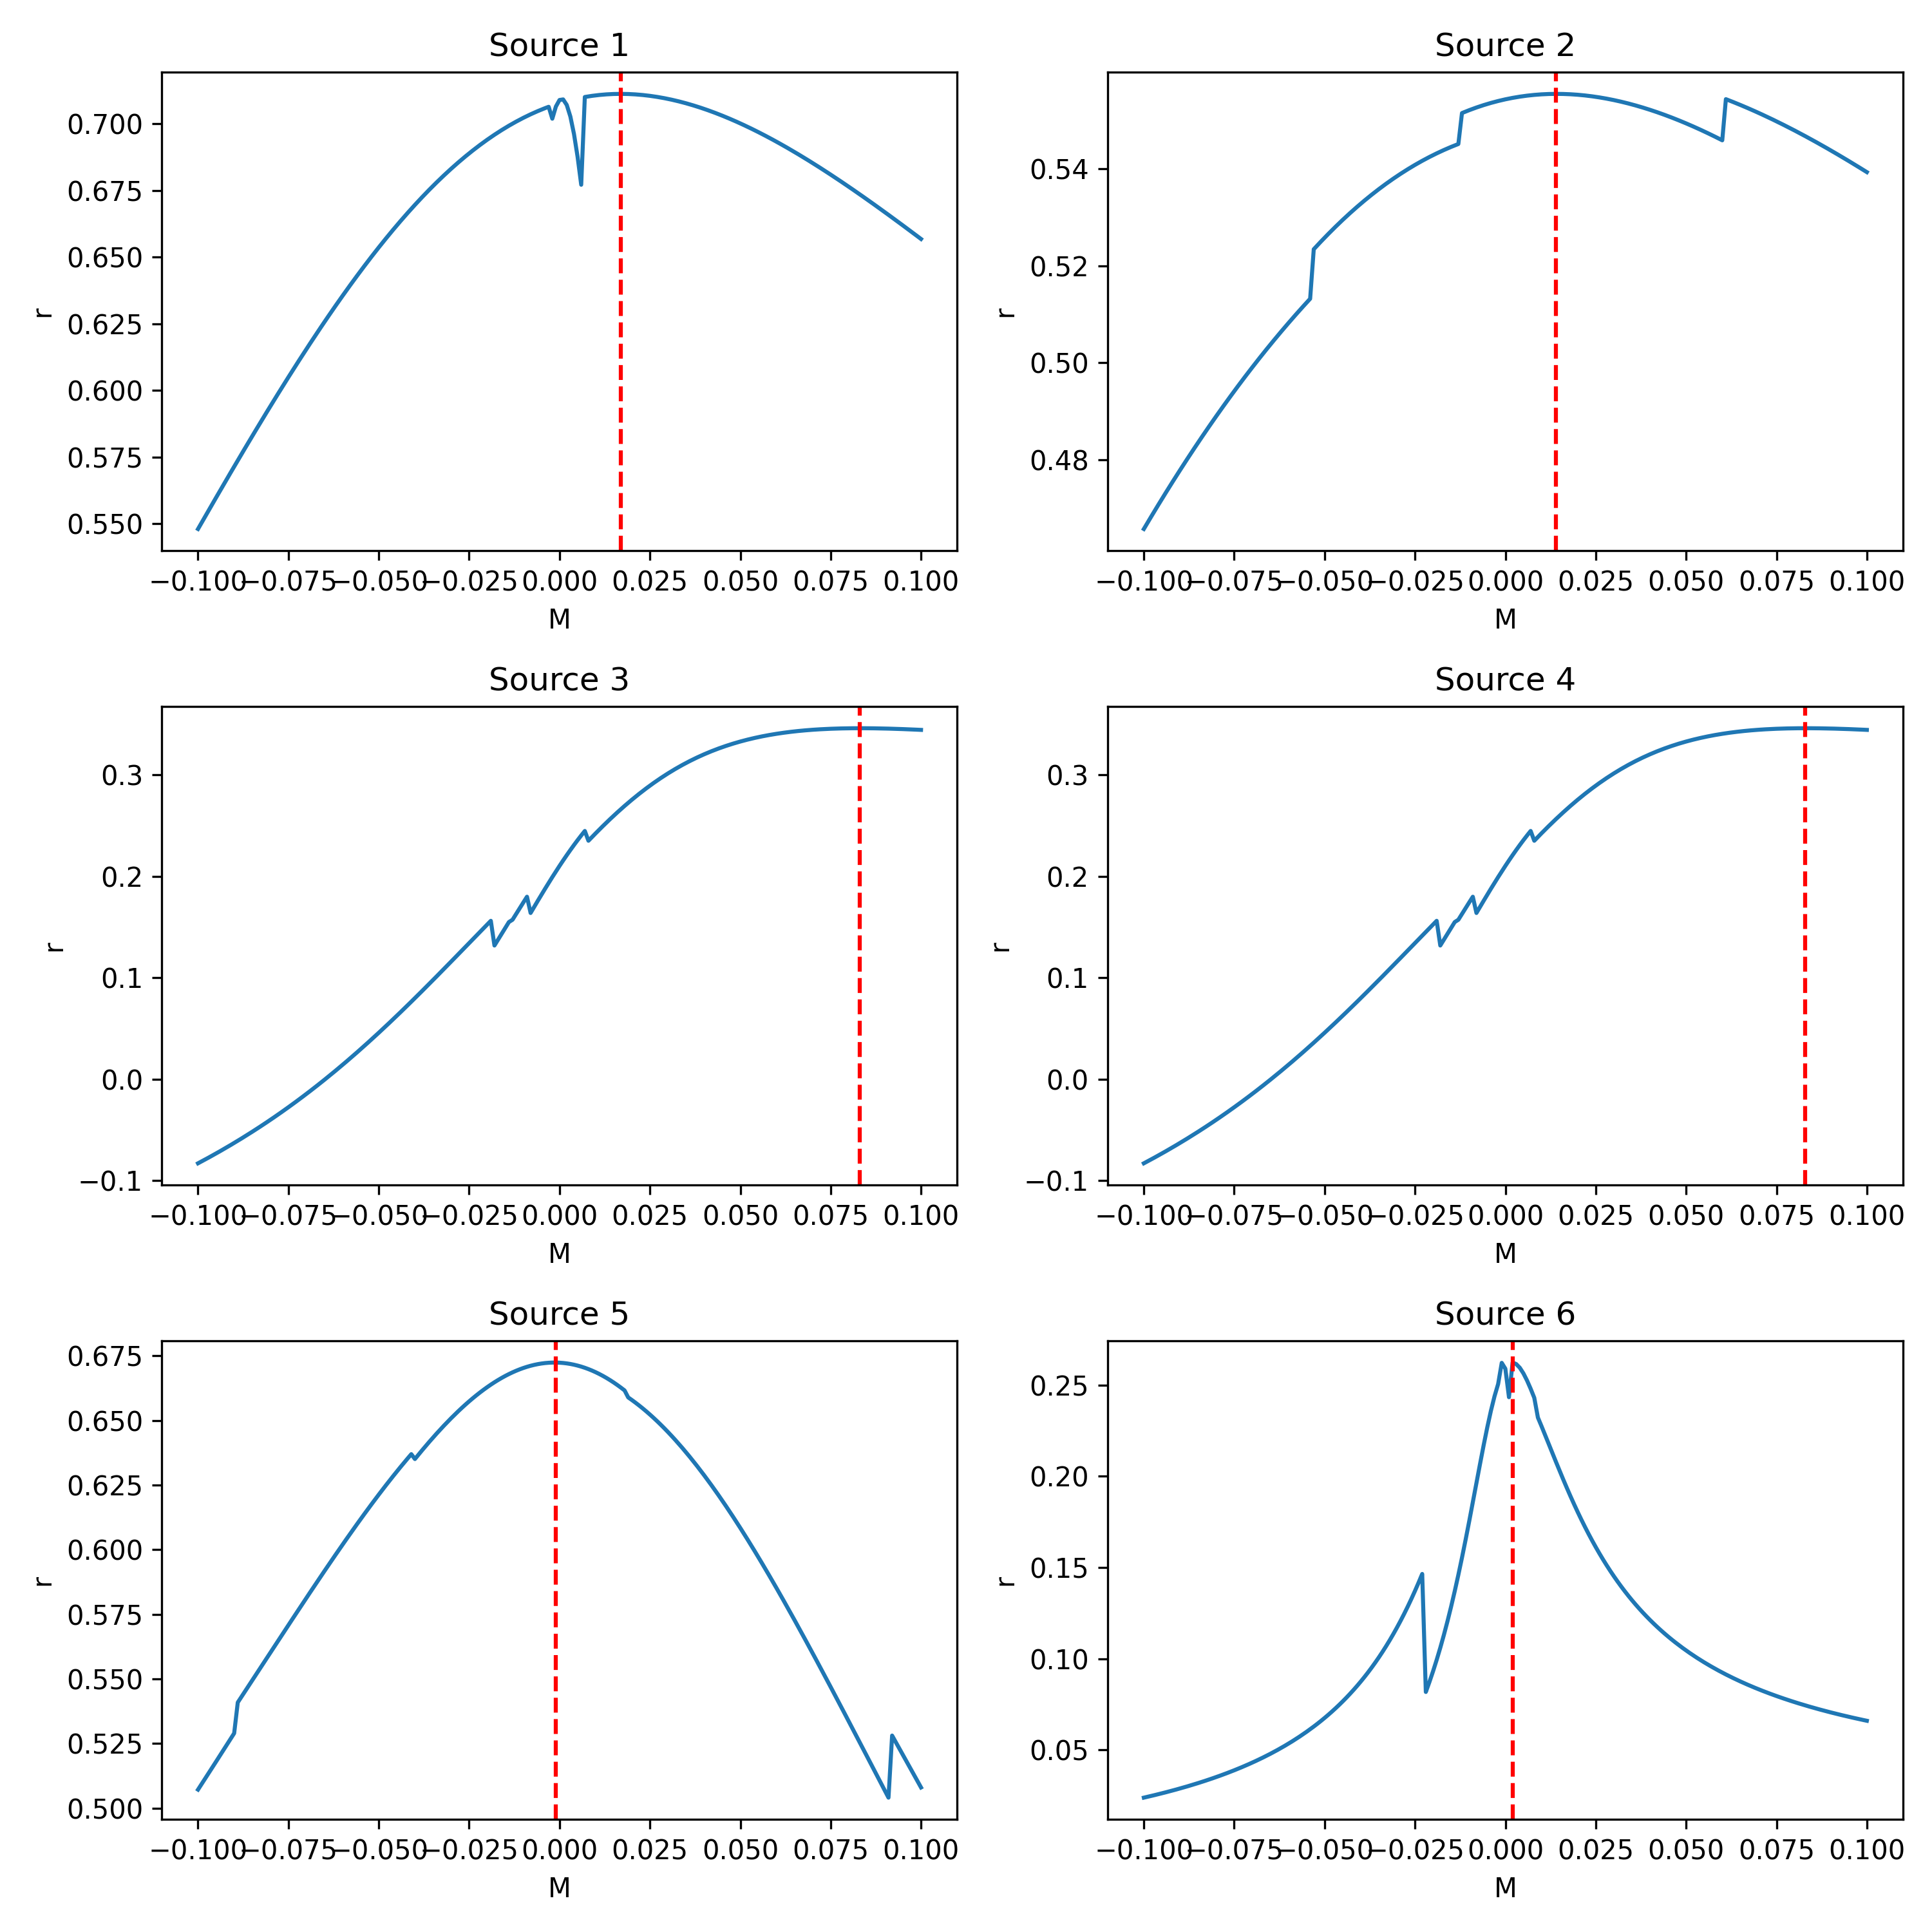
Fig 3
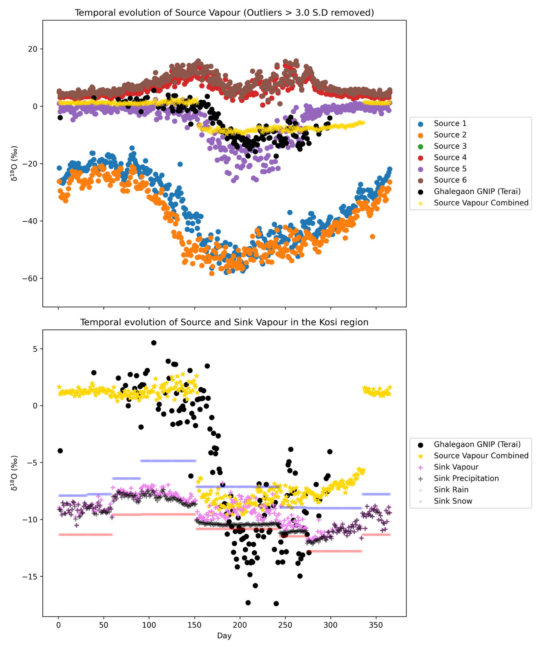
Fig 4
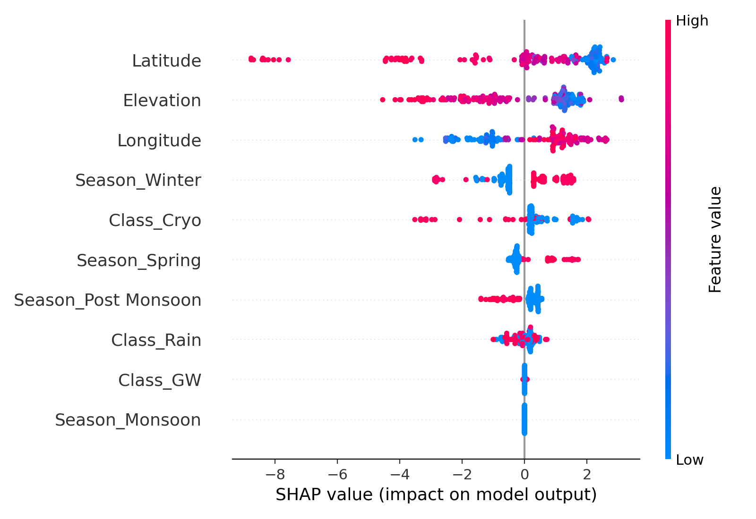
Fig 5
Analysis of filtered source contributions (Fig. 1) reveals that a subset of marine and continental vapour origins dominate the moisture budget during identified atmospheric river (AR) events, with the spatial filtering highlighting persistent transport corridors. The source vs. evapotranspiration (ET) relationships (Fig. 2) indicate that for key oceanic origins, higher ET aligns with more depleted δ¹⁸O values, consistent with enhanced evaporation under lower humidity conditions. This contrasts with certain continental sources, where ET appears decoupled from isotopic composition, suggesting post-source modification during transport. The r–M relationships per source (Fig. 3) show distinct clustering, with stronger correlations between moisture flux magnitude (M) and isotopic depletion for marine origins, supporting the hypothesis that AR events with stronger moisture transport are associated with more depleted vapour signatures at the target site.
The δ¹⁸O boxplot comparison (Fig. 4) further clarifies these source–signal linkages: sources with medians and interquartile ranges closely matching Ghalegaon’s precipitation isotopic composition are those most directly contributing vapour during AR landfall, while isotopically distinct but highly variable sources likely act as circulation markers rather than direct suppliers. This interpretation aligns with the SHAP summary analysis (Fig. 5), where high feature importance scores are attributed to both isotopically aligned sources and circulation-sensitive predictors, indicating that the model leverages a combination of direct vapour tracers and dynamical indicators to resolve AR-related δ¹⁸O variability. Collectively, these findings strengthen the case that AR-driven precipitation isotope signatures at Ghalegaon are shaped by a small set of dominant moisture origins, modulated by large-scale transport intensity and post-source atmospheric processing.

Results and Discussion
Our analysis of moisture source contributions during atmospheric river (AR) events demonstrates that the isotopic composition of precipitation at Ghalegaon is shaped by a limited set of dominant vapour origins and their associated transport dynamics. Spatial filtering of back-trajectory source fields (Fig. 1) identifies persistent marine corridors and select continental regions as the primary moisture suppliers. The most influential marine sources are aligned along subtropical and tropical oceanic pathways, suggesting a consistent advective link between ocean evaporation hotspots and AR landfall in the central Indian region. Continental contributions, while present, are less spatially continuous and more event-specific, likely reflecting transient recirculation and regional recycling.
Examining the relationship between source δ¹⁸O signatures and evapotranspiration (ET) (Fig. 2) reveals a process-based separation between oceanic and continental origins. For marine sources, higher ET rates are associated with isotopically depleted vapour, consistent with kinetic fractionation during strong evaporation under low humidity conditions. In contrast, continental sources show weaker or no systematic ET–δ¹⁸O relationships, indicating that isotopic characteristics are more strongly influenced by downstream atmospheric mixing, precipitation–evaporation cycling, and moisture recycling processes rather than by the initial ET flux at the source.

The role of transport intensity is further elucidated by correlations between moisture flux magnitude (M) and source δ¹⁸O (Fig. 3). Marine sources display clear negative correlations, indicating that stronger AR moisture transport delivers more isotopically depleted vapour to the receptor site. This is consistent with the advection of unmodified marine vapour along high-velocity AR pathways. In contrast, continental sources generally exhibit weaker correlations, again reflecting greater isotopic modification during transport and a less direct connection to Ghalegaon precipitation composition.

Boxplot comparisons of δ¹⁸O across all sources and Ghalegaon precipitation (Fig. 4) provide an integrative perspective. Sources whose medians and interquartile ranges closely match the observed local precipitation signature are inferred to be direct contributors during AR events. Isotopically distinct but variable sources, while not major direct suppliers, still play an important role as indicators of circulation patterns and synoptic-scale variability associated with AR development and persistence.

Finally, the SHAP feature importance analysis (Fig. 5) quantifies the relative contributions of model predictors to AR δ¹⁸O variability at Ghalegaon. The model consistently assigns high importance to both isotopically aligned marine sources and large-scale circulation-sensitive variables (e.g., wind vectors, transport strength, and humidity gradients). This dual sensitivity highlights that predictive skill in our machine learning framework emerges from combining direct isotopic tracers of moisture origin with dynamic indicators of AR structure and intensity.

Taken together, these results provide a coherent, process-oriented explanation for the δ¹⁸O signatures observed in AR-related precipitation. A small number of dominant marine moisture sources, modulated by large-scale transport intensity, directly shape the isotopic composition at Ghalegaon, while secondary continental and circulation-related influences provide additional predictive context through their association with AR structure. This integrated framework strengthens the linkage between observed precipitation isotope variability and the coupled dynamical–hydrological processes that define AR events in the South Asian monsoon domain.

